I Summary

Pets, such as dogs, have always been a large part of human’s life. …
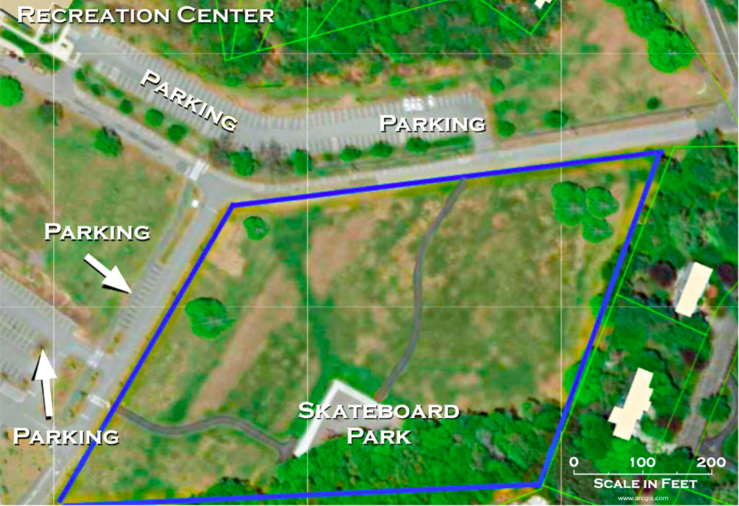
Dogs parks is fenced-in outdoor area where people and their dogs can play together, a playground for dogs to be unleashed and play freely with other dogs. It has become increasing popular for USA and Canada. For example, the city of Calgary in Alberta, Canada has 10 dog parks for a city of 1.3 million residents, and the city of Boise in Idaho, US has 6.3 dog parks per 100,000 residents. It has great benefits for both dogs and owners.
The town of Middleville Director of Parks & Recreation have wanted a Middleville dog park in the site below, with it being smaller than an acre, and keeping the existing skateboard park just as it was before. Some important aspects must be noted at first, shape and size of the dog park, features included in the dog park, cost of the materials and building of the dog parks, and cost of maintaining the park. …
The shape and size of the dog park have no particular restrictions. We decided it to be a parallelogram that is along the border of the blue outline to the up right corner. With it size about to be one acre. The dog park will be divided to Resting Area, area for dogs to play. The materials of the park will include the fence that surrounds each area, hydration stations for the dogs to drink, trash cans, Clear signage about rules and expectations for use of the park, and other necessary features.

II Dog Park
2.1 Dog Park Drawing
2.2 BOM
Bill of Materials
Item number | Description and size | Amount Needed | Cost per Item | Total Cost
1
2 | Pet Rehydration Station XL | 9 | $383.01 | $3447.09
3
4 | Trees
5
6
7

2.3 Maintaining dog park
Maintaining the dog park won’t cost that much.
2.4 Adjustments
2.5 Summary
III Letter
IV Reference

